

YOUNG WOMEN’S CHRISTIAN ASSOCIATION
OF MALAWI
(YWCA)

ANNUAL REPORT 2025

ORGANIZATIONAL PROFILE
The Young Women’s Christian Association (YWCA) of Malawi is an affiliate of the World YWCA, established in Malawi in 1998 and registered with the NGO Board (now the NGO Regulatory Authority or NGORA) in 2003. YWCA is a non-governmental organization (NGO) that is both women and youth-led, membership-based, and focused on the empowerment of adolescent girls and young women (AGYW). Our vision is to create a fully inclusive society where justice, peace, health, human dignity, freedom, and environmental care are fostered and sustained through women’s leadership. YWCA values all human beings, regardless of race, nationality, class, or religion, and aims to promote understanding and cooperation across different ethnicities, races, and cultures. The core values of YWCA include volunteerism, diversity, tolerance, mutual respect, integrity, and accountability.
YWCA is committed to advocating for the improved quality of life for AGYW by empowering them to assess and express their needs, and to demand services from relevant authorities through active participation in decision-making processes. The organization also works to raise awareness of their rights and responsibilities as productive citizens while promoting self-reliance and personal development through education, skills training, and economic empowerment. While YWCA’s main focus is on AGYW, the organization also includes adolescent boys and young men (ABYM) in its activities on a smaller scale, especially given the absence of a Young Men’s Christian Association (YMCA) in Malawi.
YWCA provides developmental assistance in several key areas, including HIV and Sexual Reproductive Health and Rights (SRHR), Mental Health and Psycho-Social Support (PSS), Child Protection (CP), Gender-Based Violence (GBV) and Ending Violence Against Women and Girls (EVAWG), Political Empowerment of [Young] Women (PEW), Leadership, Governance and Active Citizenship, Education, Economic Empowerment and Self-Reliance (SR), and Early Childhood Development (ECD). The organization also participates in humanitarian work within the Protection, Health, and Nutrition clusters. YWCA’s services are currently available in the districts of Blantyre, Chikwawa, Machinga, Mulanje, and Zomba.
KEY ACTIVITIES & OUTPUTS
In 2025, YWCAs interventions were focused on Leadership, Governance and Active Citizenship; Entrepreneurship; GBV; HIV & SRHR; and menstrual Hygiene and management. These interventions have been documented as follows:

DEVELOPMENTAL ASSISTANCE
- HER Voice Fund
Project title: AGYW for Active Citizenship
Donor: Global Fund through ViiV Healthcare for Positive Action
Principal recipient: Y+ Global
Country Lead: Y+ Malawi
Implementing partner: YWCA
Project location: Blantyre - T/A Machinjiri (Chilaweni & Mtenje Area Development Committees (ADCs))
Targets: Adolescent and Young People (AYP) (70% AGYW: 30% ABYM)
- AYP living with HIV
- AYP with disabilities
- AYP Key populations
- AYP in rural areas
- AYP who inject/use drugs
- AGYW who sell sex
- Pregnant AGYW and young mothers
The HER Voice Fund (HVF) is a Global Fund initiative, supported by ViiV Healthcare-Positive Action and implemented by Y+ Global in 13 priority countries. HVF is designed to enhance the meaningful engagement and leadership of Adolescent Girls and Young Women (AGYW) and community-based organizations serving AGYW in Global Fund processes and other related national initiatives. Since 2020, YWCA has been responsible for implementing HVF annually in Blantyre district through the project “AGYW for Active Citizenship,” which primarily targets AGYW from the Traditional Authority (T/A) Machinjiri – specifically from the GVHs of Chilaweni, Mtenje, and Mwamadi.
The current cycle of “AGYW for Active Citizenship,” running from June 2024 to December 2026, marks the fifth cycle of implementation. YWCA’s goal is to strengthen and support an AGYW-led movement within T/A Machinjiri, Blantyre district, with a focus on mobilizing AGYW and other Adolescents and Young People (AYP) to increase their uptake of key health services. At the same time, the project actively engages duty bearers and stakeholders to improve the delivery of critical youth development services in the region. Over the past year, 2025, YWCA, through the HVF-supported “AGYW for Active Citizenship” Project, has made significant strides in empowering AGYW across the targeted communities. The project continued to focus on enhancing young women's economic participation, leadership, and governance, expanding access to Sexual and Reproductive Health and Rights (SRHR), and promoting meaningful civic engagement. Key achievements include:
- Meeting with District Aids Coordinating Committee
YWCA supported four AGYWs to meaningfully participate in the District AIDS Coordinating Committee (DACC) meeting. This ensured that the voices and priorities of young women inform district-level planning and coordination. During this meeting, YWCA gave an update on the progress of the project, challenges encountered so far and way forward. Later the AGYWs who are also Youth Community Based Distribution Agents were also given a chance to present their work as well as challenges they are experiencing from their various communities. The platform also gave them the opportunity to lobby for services needed in their area from the duty bearers. The AGYWs/YCBDAs did highlight the high demand for family planning services among the youths especially the pills and condoms. However, when they go to their health facilities they are told there is low supply of these commodities. Condom coordinator for the district acknowledged the low supply of family planning commodities like pills and attributed it to the effect of the stop order of PEPFAR support from USAID. However, she said the condoms are available; the issue is just poor coordination between in charge health workers from Health facilities and the main district hospital when it comes to ordering supplies. She promised to look into the matter and make sure the said health facilities get the supplies as requested.

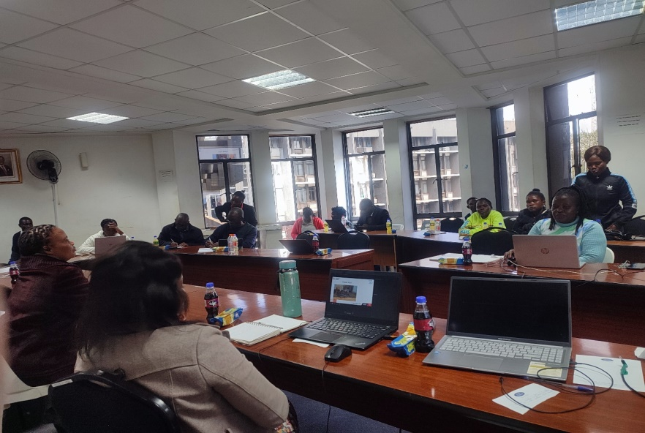
Figure 1: Bertha one of the AGYWs/CBDA presenting the activities they do and challenges faced to the District AIDS Coordinating Committee members
- Training of AGYW in Governance and Leadership
YWCA trained 32 AGYWs from TA Machinjiri under Chilaweni an Mtenje ADCs in governance and leadership, equipping them with essential skills to engage in decision-making and community development processes. The training aimed at strengthening young women’s confidence and increase their representation in leadership spaces. The pictures below show AGYW during group work presentations and Community Development officer during facilitation session.

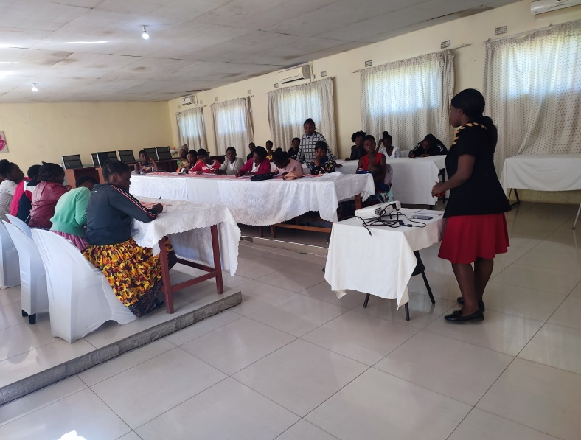
Figure 2: AGYWs during the session at Shalom Palace

- Entrepreneurship Training for AGYWs

YWCA conducted a one day entrepreneurship training session designed to equip 34AGYWs and 4 ABYM with essential business development skills. These session focused on practical knowledge including financial literacy, product development, and marketing and income-generating strategies. The training has enabled participants to take confident steps toward economic independence.
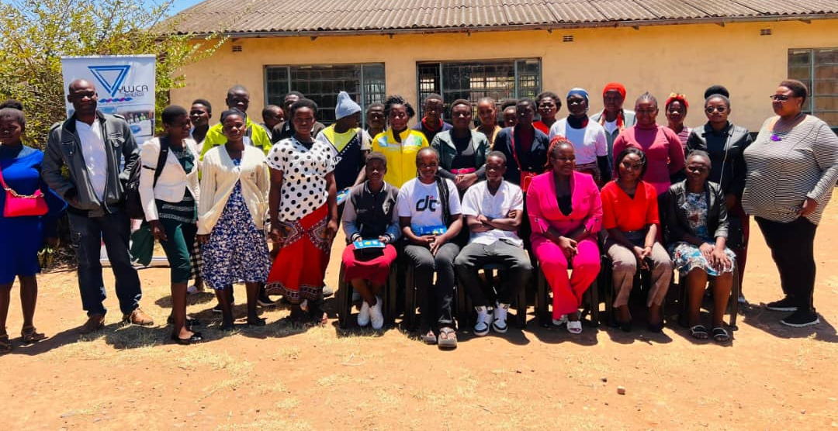
Figure 3: Linda Phiri (HVF Ambassador in Malawi) in Pink suit with AGYWs and state stakeholders during entrepreneurship training
- Strengthening Civic Engagement
To foster active youth participation in governance, the project facilitated an interface meeting with local government leaders and parliamentary election candidates in our targeted communities. This platform gave AGYWs and AYP the opportunity to express their priorities, raise questions, and highlight challenges affecting their wellbeing. The dialogue strengthened relationships between young women and policymakers while encouraging accountability and inclusion. A written commitment agreement was signed between the youths and each of the aspiring candidate as a way of holding them accountable should they be voted into power. Pictures below shows some of the youths and shadow MPs and councilors during the discussion.

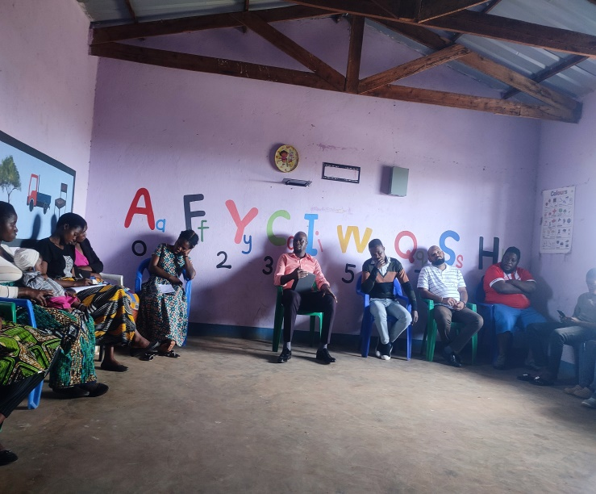
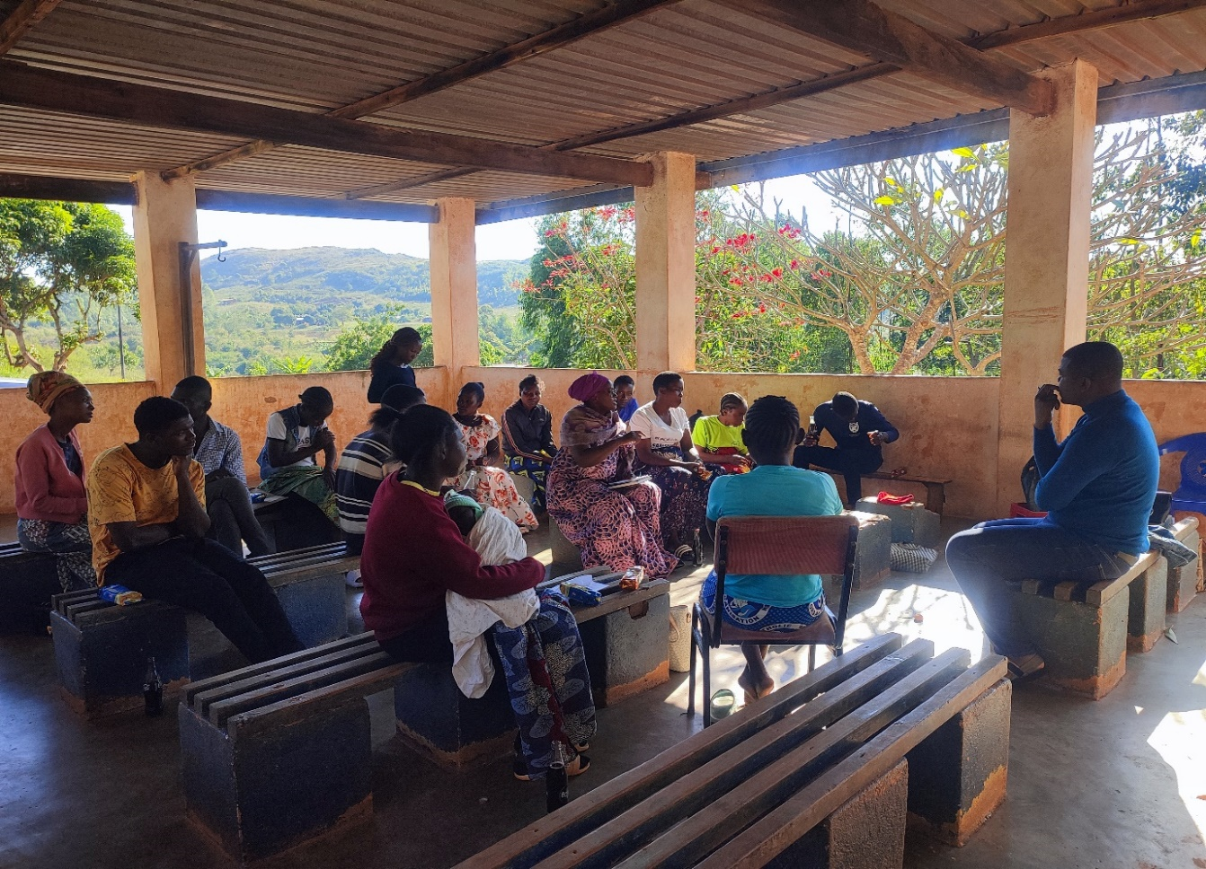
- Supported Access to Youth-Friendly Health Services Service Reach and Impact

An impressive 6,756 AGYWs and AYP accessed SRHR services through project-supported platforms like outreach activities, trained Youth Community-Based Distribution Agents health facilities and awareness programs. This demonstrates a growing trust in youth-friendly services and highlights the project’s role in facilitating access to essential health resources. Through Her Voice Fund, YWCA supported 6 Youth Friendly Health Services (YFHS) outreach sessions in the targeted communities of TA Machinjiri.
- Targeted Awareness Campaigns on SRHR and HIV
The quarter also saw intensified awareness campaigns focusing on existing YFHS and the critical role they play in shaping young people's SRH, HIV prevention, and life skills. The Young Women’s Christian Association (YWCA), in collaboration with district health authorities and community structures, rolled out a series of awareness campaigns aimed at increasing young people’s knowledge of Youth-Friendly Health Services (YFHS) available in local health facilities. The initiative combined digital campaigns, community engagement meetings, and football bonanzas to reach youth through accessible and relatable platforms. YWCA implemented targeted digital campaigns using social media and mobile platforms. These online messages highlighted the availability of youth-friendly services including HIV Treatment Adherence and Cervical Cancer Screening and Human Papillomavirus (HPV) Vaccination. The digital approach helped reach young people who may not attend community events but are active online.
YWCA also held 3 engagement meetings with youth networks and health workers to strengthen understanding and support for YFHS. These sessions emphasized: The importance of accessing SRH services without fear or stigma; the role of CBDAs in providing confidential, youth-friendly assistance and Breaking myths and misconceptions surrounding contraception and HIV services. The meetings created spaces where youths could ask questions, receive accurate information, and learn where to seek services. The pictures below show some of the youths during engagement meetings and the District Youth Officer in one of the sessions.
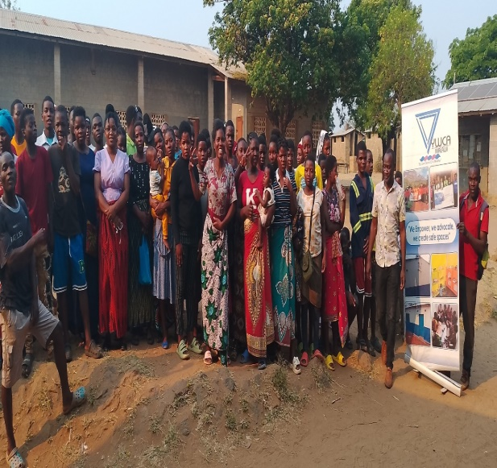
Figure 4: some of the Youths from chilaweni youth network during engagement meetings at Chaweta
To make the campaign engaging and youth-centered, YWCA hosted football bonanzas in 2 selected communities. Football, a popular sport among young people, served as an effective mobilization tool. During matches, health workers delivered short health messages during halftime and directed participants to nearby service points offering condoms, HIV self-testing kits, and other SRH services. The bonanzas created a fun, interactive environment that encouraged participation and openness, helping youths connect with health workers in a relaxed setting.
The combined strategy of digital engagement, community meetings, and sports-based mobilization significantly increased awareness of YFHS among adolescents and young adults. Many young people reported a better understanding of where to access services and these campaigns reached large segments of the youth population with accurate information, helping to reduce misconceptions and promote health-seeking behavior as many young people reported were more confident in visiting health facilities for their sexual and reproductive health needs.
- Training of Key child protection structures
As part of efforts to enhance child safety and justice systems and protecting women from gender based Violence, YWCA also trained 33 key child protection and justice practitioners from community-based structures including Village Development Committee Area Development Committee, Community Victim Support Unit, District Child Protection Committee, and Area Child Protection Committee. They were trained on child protection laws and policies, with focus on child marriage prevention, and responding to Violence Against Children (VAC) and women especially AGYW and strengthening referral system.
B. NGO Gender Coordination Network (NGO-GCN)
Project title: Local Voter observation
Donor: UN Women
Country Lead: NGO-GCN
Implementing partner: YWCA
Project location: Blantyre rural, Mpemba

In September 2024, as part of the accreditation process by the Malawi Electoral Commission (MEC) for election observation, NGOGCN engaged its member organizations to nominate volunteers for accreditation as election observers. YWCA nominated its Project Officer, Ms. Vitumbiko Mkinga, who was successfully accredited under the NGOGCN partnership and participated in observing the national elections held on 16 September 2025, specifically in Blantyre Rural, Blantyre South West Constituency.
The voting process was orderly, and no irregularities were observed. Of particular note was the collection of gender- and disability-disaggregated data. At the time of observation, voter turnout was low; however, among those present, female voters outnumbered their male counterparts. It was also observed that women held key decision-making roles at the polling station, with the Presiding Officer being female. Although the staffing reflected strong female representation, gender balance was not fully equitable, with six female staff members compared to one male. Additionally, the polling environment was safe and accessible, and persons with disabilities, including those with physical and visual impairments, were adequately supported to cast their votes.
C. NGO Gender Coordination Network (NGO-GCN)
Activity: Annual General Meeting
Venue: Lilongwe Cross-roads Hotel
Date: 18-19 December, 2025

YWCA Malawi participated in a two-day meeting organized by the NGO Gender Coordination Network (NGO-GCN) in Lilongwe on the 18th and 19th of December. The meeting brought together members, board members, and stakeholders to review the Network's performance for the past year, discuss governance issues, and set priorities for the upcoming year.
A key highlight was the presentation and adoption of a position paper on the Prevention of Domestic Violence Act, following its review by the Pamodzi Kuthetsa Nkhanza Consortium (WOLREC, GENET, and WAG), with funding from FCDO. The review aimed to ensure the Act remains relevant to the challenges affecting women and girls. The position paper will be presented to the Minister of Gender. Mrs. Maggie Kathewera Banda, Executive Director of WOLREC and Chairperson of NGO-GCN, emphasized the importance of such advocacy engagements in identifying gaps in the Act. She also presented the Chairperson’s report, highlighting the Network's efforts to increase women’s participation in leadership, governance, and decision-making. Key activities included enhancing women’s capacity to run for elective positions, training 78 party monitors, and conducting electoral process reflections.
However, despite these achievements, the Network faces ongoing challenges like violence against women during elections, limited resources for the Political Empowerment of Women Strategy, and reduced international funding, particularly affecting NGO-GCN operations. Social and economic issues in Malawi also hinder development efforts, and stronger advocacy on the Gender Equality Act was called for. The Administrative Report by Mr. David Odali highlighted the requirement for members to pay outstanding fees by March 2025 and reported on the acquisition of land valued at seven million Malawi Kwacha. This land, near MUBAS, will enhance the Network's credibility and potentially attract donor support for office development. The Network also continues to work on fundraising efforts, though financial challenges remain, including the cancellation of a 100 million Malawi Kwacha project with UNICEF due to funding constraints.
In the meeting's resolutions, members agreed to focus on increasing resource mobilization, engaging communities on gender equality, and improving the Network’s visibility to attract new members. Membership fees will be raised to MK100,000 by March 2026, and annual financial reports will be prepared to enhance transparency and accountability.
In conclusion, despite facing significant financial and operational challenges, NGO-GCN is committed to advancing gender equality, women’s rights, and women’s participation in leadership and governance in Malawi.

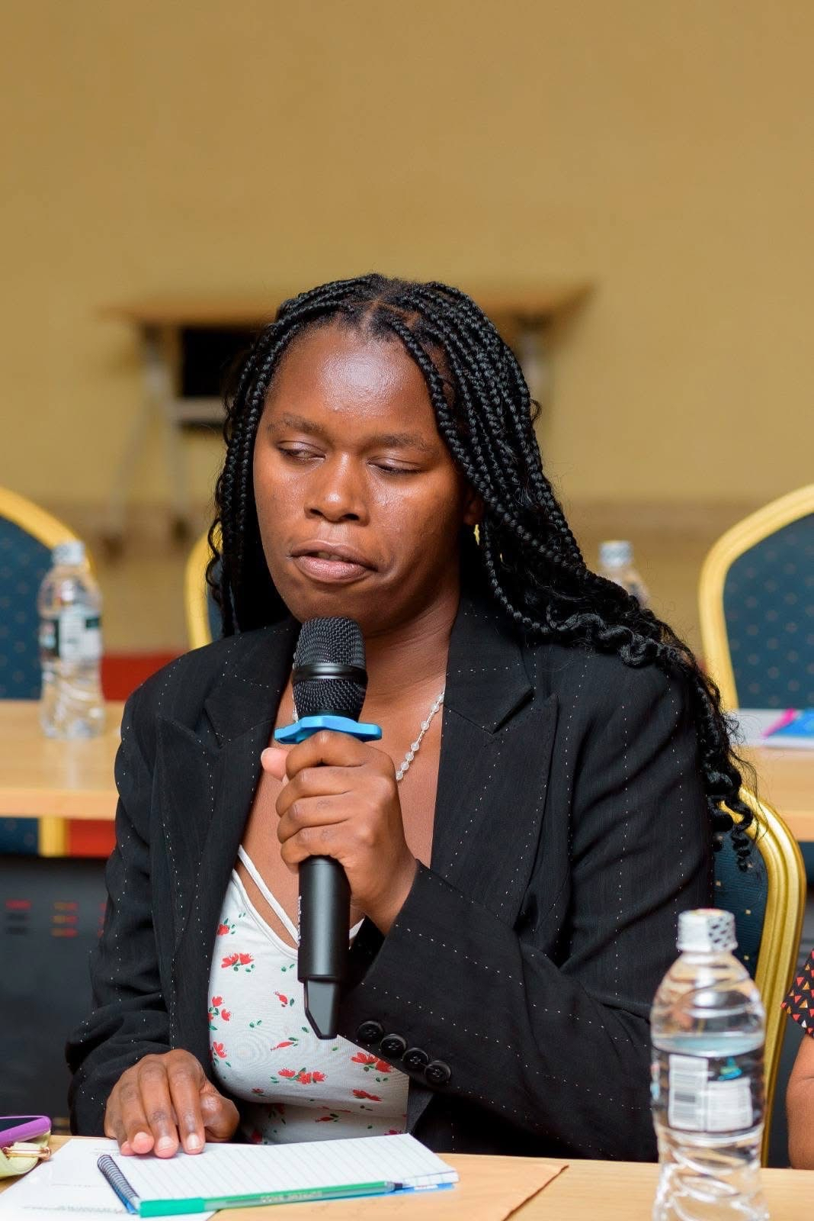
Figure 5: YWCA internee contributing to discussions during the meeting
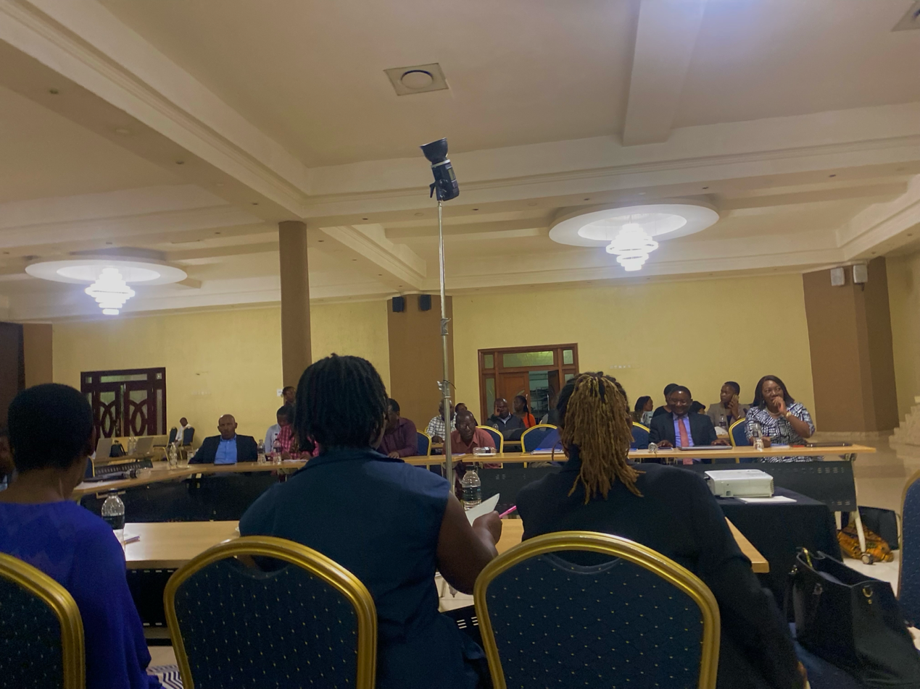
Figure 6: Members of the NGO Gender Coordination Network during the two-day engagement meeting
D. WORKSHOP ON CIVIL SOCIETY PLATFORM CHARTER DEVELOPMENT AND RESOURCE MOBILISATION
Date: 23-24June, 2025
Venue: Cross-roads
Organizedby: Common wealth of Learning(COL)
Participants: Representatives from Civil Society Organizations (CSOs)
Facilitator: Consultant Ricardo Mensah
Introduction
YWCA participated in a two-day workshop which was conducted to support the development of a Charter for the Civil Society Platform and to enhance participants’ capacity on resource mobilization strategies. The workshop aimed to strengthen the operational framework and sustainability of civil society networks by fostering inclusive participation and equipping members with effective tools for resource generation.
Objectives
- CSP Charter framework: Build the Blueprint; to develop and validate a draft Civil Society Platform Charter.
- To enhance participants’ understanding of governance, roles, and responsibilities within the platform.
- To equip CSOs with practical strategies and tools for resource mobilisation.
- To encourage collaboration and knowledge sharing among civil society actors; amplifying the collective voice
Remarks
The workshop was officially opened by Aubrey the Project Coordinator for Empowering Women and Girls from Concerned Youth Organization (CYO), who gave a brief background about the Empowering Women and Girls (EWG) Project in Malawi which is being supported by Global Affairs Canada. He stated that the workshop was a follow-up action to the commitment that was made in 2024 by Veronica Sudesh from Commonwealth Of Learning who committed to supporting the development of Civil Society Platform charter and a Resource mobilization strategies in Malawi. He emphasized the importance of a unified voice and governance structure for civil society to influence development outcomes effectively.
Key Sessions:
- Overview of Civil Society Platforms – Understanding the need and purpose of a formal Charter including CSP foundations and models
- Drafting the Charter – Participants reviewed and discussed key components including mission, vision, values, membership criteria, governance structure, and decision-making processes.
- Resource mobilization capacity building; resource mobilization assessment, proposal development essentials and Donor Engagement Strategies; Strategies for Resource Mobilisation – Sessions focused on proposal writing, building partnerships, local fundraising techniques, and income-generating activities.
- Action Planning ; established 90-day action plan for continued progress
Key Outcomes
- Participants gained increased knowledge on strategic resource mobilisation.
- Networking and collaborative linkages were enhanced among civil society actors.
- A CSP steering committee was voted and endorsed by the participants present to facilitate the 90-day action plan. As a representative from YWCA, Ms Vitumbiko Mkinga was selected as a Vice chairperson for the Steering committee that has membership of 9 CSO representatives.
The workshop successfully met its objectives, laying a foundation for a more structured and sustainable Civil Society Platform. COL has expressed continued commitment and support which will be key in driving the platform’s goals forward.
The Executive Director for Concerned Youth Organization (CYO) made final remarks by thanking the facilitator for the wonderful sessions we had. He assured the facilitator that the knowledge impacted in the CSOs will be of great value especially when it comes to resource mobilization in working in consortiums as it is the current approach most donors are preferring. Therefore he called upon the individual CSOs to foster collaborations through this Civil Society Platform.

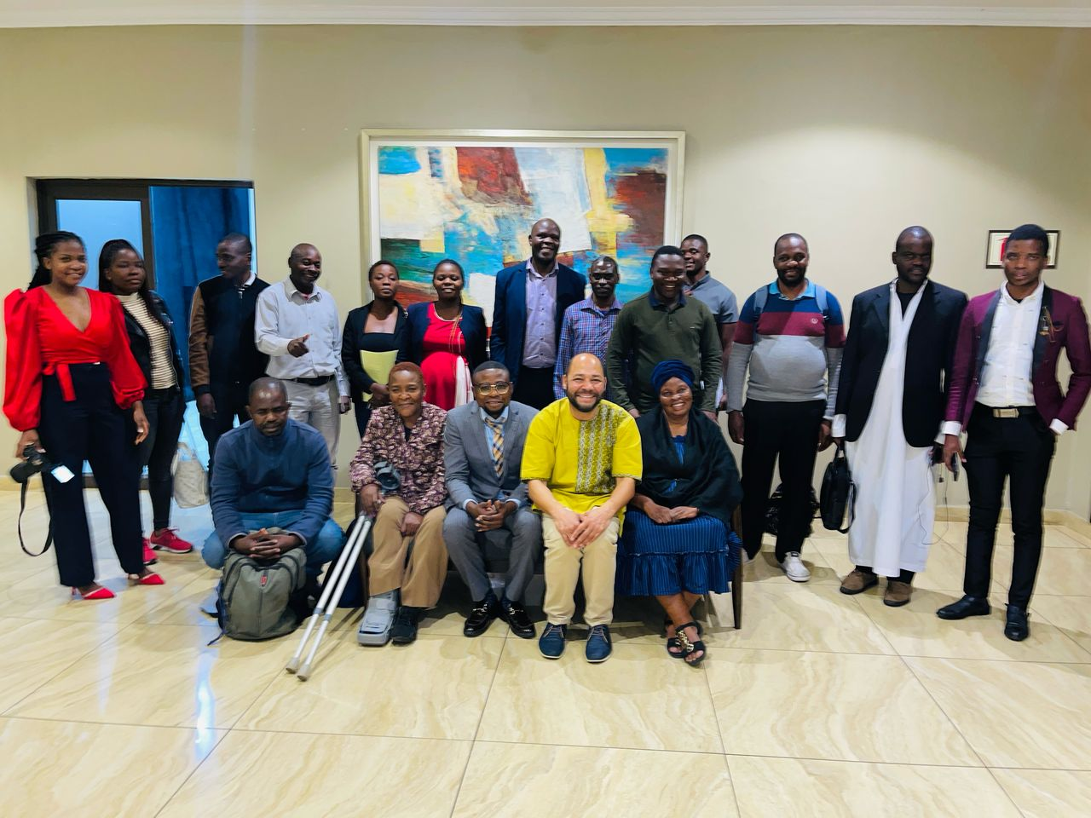
Figure 7: Some of the CSO members with the facilitator Consultant Ricardo Mensah (in yellow)
E. YWCA Malawi Annual General Meeting
The YWCA Malawi conducted its Annual General Meeting (AGM) on 11th October 2025. The meeting brought together members, board members, and stakeholders to review the organization’s performance for the past years. The meeting focused on several key aspects of the organization’s growth and future. A major highlight was the election of the new board. All 13 positions, which had been advertised in advance, went uncontested, and the elected members included Caroline as Board Chair, Victoria Nnensa as Board Secretary, and Henderson Mhango as the Finance and Fundraising Chairperson, among others. The new board members were sworn in by the Executive Director, marking an important leadership transition within the organization.
Another significant aspect of the meeting was the approval of the strategic plan. The plan was presented by Irene Ntonga and received approval from the members, signaling the organization’s direction for the upcoming years. The strategic plan is expected to guide the YWCA’s activities, including its approach to funding, outreach, and program development.
In terms of funding and membership contributions, the chairperson reported that 2025 had been a positive year for membership contributions, with most members, including those from various branches, paying their dues. However, the chairperson raised the issue of whether the current membership fee should remain the same or be revised, particularly for those in urban areas. The organization also faces a challenge in its reliance on donor funding, with the chairperson noting that low staff retention is partly due to a lack of sustainable, independent income. This led to discussions about the need for fundraising initiatives to reduce dependence on donor projects and ensure long-term sustainability for the organization.
These discussions, combined with the election of a new board and approval of the strategic plan, were essential steps in ensuring the continued growth and sustainability of YWCA Malawi.
F. Menstrual Health and Hygiene Management
Project title: Girl Speak-Period
Donor: Seniours Without Donors, Denmark
Implementing partner: YWCA
Project location: Zomba – Sakata Primary school, T/A Nkagula
Target: School Girls in puberty stage/Adolescent
- Mother group members
- School Boys
- Initiation counsellors
- Parents and local leaders
- School management committee
The Young Women Christian Association of Malawi (YWCA) is currently implementing the Girl Speak-Period pilot project, with financial support from Seniors Without Borders, Denmark. The six-month project, which began in September 2025 and runs through February 2026, is being implemented in Zomba District, specifically at Sakata Primary school under the Nkagula Traditional Authority. The aim of the project is to establish a model school by educating adolescent girls about menstruation and providing them with menstrual pads, enabling them to remain in school and complete their basic education. With availability of funding, the plans are to extend to other 2 schools in the district and Machinga.
Key achievements so far this year include conducting induction meetings with the Zomba District Council, the Youth and Gender Technical Working Group, and the Area Executive Committee, as well as carrying out a benchmarking survey at Sakata Primary School. The project was approved by the DEC, and all other structures have warmly welcomed it, expressing a strong willingness to support and collaborate.
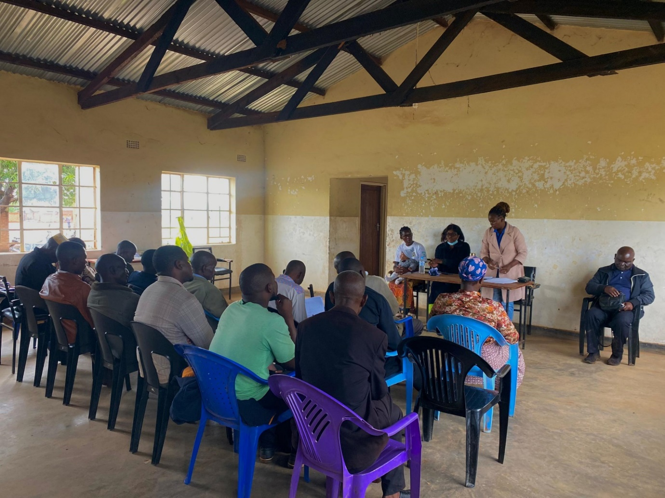
Figure 8: Project Officer briefing the AEC on the project

ANNEXES
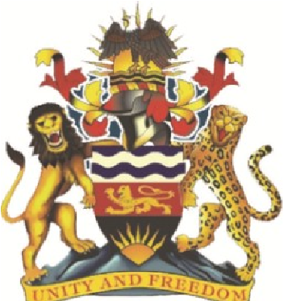

REPORT ON YOUTH SENSITIZATION CAMPAIGNS CONDUCTED BY YOUNG WOMEN CHRISTIAN ASSOCIATION (YWCA) OF MALAWI AND BLANTYRE DISTRICT HEALTH OFFICE (DHO)

SUBMITTED TO:
PROJECT OFFICER FOR YWCA
CC: THE PRINCIPAL HELTH PROMOTION OFFICER
Bcc: THE CHIEF PREVENTIVE HEALTH OFFICER

SUBMITTED BY:
GEORGE KHONJE
(HEALTH PROMOTION OFFICER)

DATE SUBMITTED:
12th November 2025
REPORT ON YOUTH SENSITIZATION CAMPAIGNS
Introduction
- The Young Women Christian Association (YWCA) of Malawi with funding from HER VOICE, in collaboration with the Blantyre District Health Office (DHO), conducted a series of youth sensitization campaigns in Blantyre Rural from 8th to 9th November 2025.
- The sensitization events were designed to reach youth in a fun, interactive, and inclusive manner by integrating sports (football bonanzas) with health education and on-site service provision. The key message shared throughout both events was that young people can freely access SRH services from health facilities as well as from Community-Based Distribution Agents (CBDAs) who are trained to provide youth-friendly support at community level.
Venue of events
The two events were held at:
- Chipande (Chaweta School Ground) on 8th November 2025, and
- Ntenje (Seyama Catholic School Ground) on 9th November 2025.
Key Stakeholders and Participants
The events had the following representatives, including:
- The YFHS Coordinator (Blantyre DHO), Health Promotion Officer (Blantyre DHO), YWCA Malawi team as well as District Youth Office representative.
- Community leaders (Group Likomba and Group Chilipa at Chipande), CBDAs, youth networks and community members
Activities Conducted
- Both events followed similar formats, combining education, entertainment, and service delivery in one setting.
Opening and Community Engagement
- Each event began with welcome remarks from local leaders and officials, encouraging youths to participate actively. They highlighted the importance of knowing where to access services, addressing myths about contraception, and promoting responsible sexual behavior.
- The YWCA and DHO teams emphasized the role of CBDAs in providing confidential and youth-friendly services within communities.
Health Talks and Sensitization
Health workers conducted short, interactive sessions on topics such as:
- Importance of HIV testing and counseling, Family planning methods suitable for adolescents and young adults
- Condom use and STI prevention, Accessing health services without stigma or fear
- Youth empowerment in making informed health choices
Football Bonanzas
At both Chipande and Ntenje, football matches were the highlight of the day.
- In Chipande, Group Likomba competed against Group Chilipa, attracting a huge turnout of supporters.
- In Ntenje, the Ntenje Team faced off with the Youth Network Team, generating the same level of excitement and participation.
The matches created a relaxed, fun environment that encouraged learning and openness. Health workers used halftime breaks to deliver brief health messages and invite participants to service points.
Summary of Commodities and Services Distributed
During the two youth sensitization events, a range of sexual and reproductive health services were provided to participants from the surrounding communities.
- At Chipande (held on 8th November 2025), a total of 576 male condoms were distributed alongside 20 female condoms, 9 cycles of Progestin Only Pills (POP), and 50 OraQuick HIV self-test kits. These services were accessed by community members and youths aged between 15 and 56 years.
- At Ntenje (held on 9th November 2025), several services were also made available despite limited supplies. A total of 260 male condoms were distributed, while 7 youths accessed combined oral contraceptive pills (COCs), 2 youths received emergency contraceptive pills, and 5 OraQuick HIV self-test kits were provided. Although the quantities were smaller compared to the Chipande event, the demand for all commodities remained high, particularly for condoms and self-test kits.
- The services attracted high demand, showing a positive response from youth who were eager to learn and take responsibility for their health.

Awards and IEC Materials
At both venues, outstanding players were recognized as Man of the Match and Woman of the Match, each receiving a branded T-shirt as an award. The winning teams received cash prizes, while runners-up got consolation gifts.
The IEC materials distributed included branded T-shirts carrying the campaign message “Achinyamata, zindikilani kuti mutha kupeza thandizo la zaumoyoMu zipatala zones za kudera kwanu”, aimed at reinforcing health messages even beyond the event. These materials played a dual role as both visibility items and educational tools.
Achievements and Impact
- Large turnout of young people and strong community engagement.
- Effective collaboration between YWCA, DHO, CBDAs, and local leaders which increased awareness and confidence among youths to access health services.
- Successful integration of sports and distribution of SRH services in a youth-friendly setup.
- IEC materials (Branded t-shirts) extended message visibility in the community after the events.
Challenges Encountered
- Limited supplies of some health commodities, particularly during the Ntenje event.
- High demand for services exceeded available staff and time.
- Poor community and health facility coordination at Ntenje leading to unavailability of local leaders.
Recommendations for Future Campaigns
- Ensure adequate stock of SRH commodities and test kits for future campaigns.
- Strengthen pre-event coordination with community leaders and integration of essential SRH services including PEP and PREP to ensure sufficient service availability.
- Expand the use of branded IEC materials; especially banner to keep messages visible in communities during events.
Overall Observations
- The youth sensitization campaigns at Chipande and Ntenje demonstrated that combining sports with health promotion is an effective and innovative strategy for community engagement. Football, a popular activity among youth, served as a bridge for communicating sensitive health issues in a comfortable, non-judgmental way.
- The close partnership between YWCA Malawi, Blantyre DHO, community leaders, and youth groups fostered strong local ownership and increased the visibility of both YFHS and CBDAs. The distribution of branded T-shirts carrying campaign messages also helped sustain awareness in the communities.

Conclusion
- The two-day youth sensitization campaign successfully achieved its objectives of increasing awareness, improving access to youth-friendly health services, and promoting healthy behaviors among adolescents and young adults. The activities drew large crowds of young people, parents, community members, and local leaders. The football games served as a magnet for mobilization, while health talks and service points allowed participants to access information and commodities in a friendly and open environment.

Event Highlights in Pictures
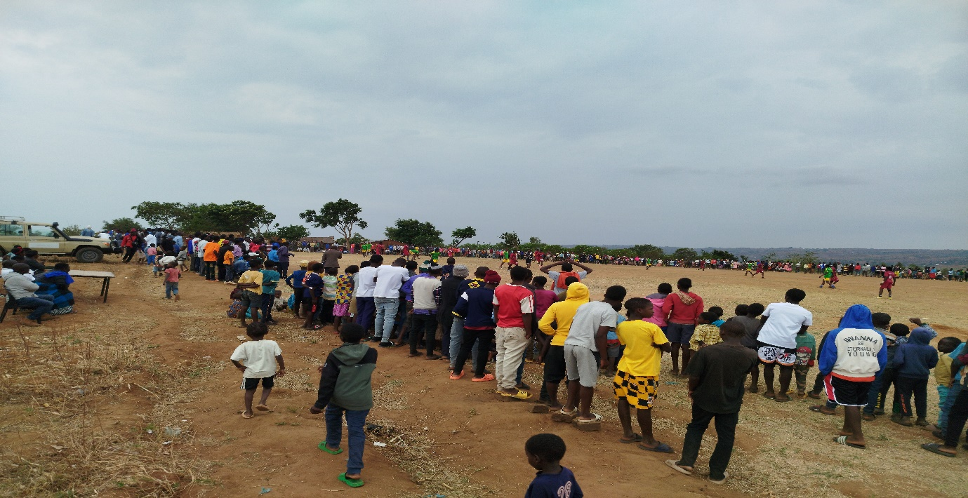
Community members watching football match (Chaweta school ground)
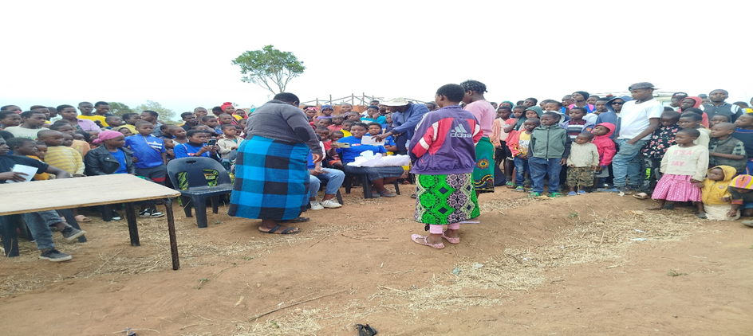
Presentation of awards to best performing players by Group Likomba (Chaweta school ground)

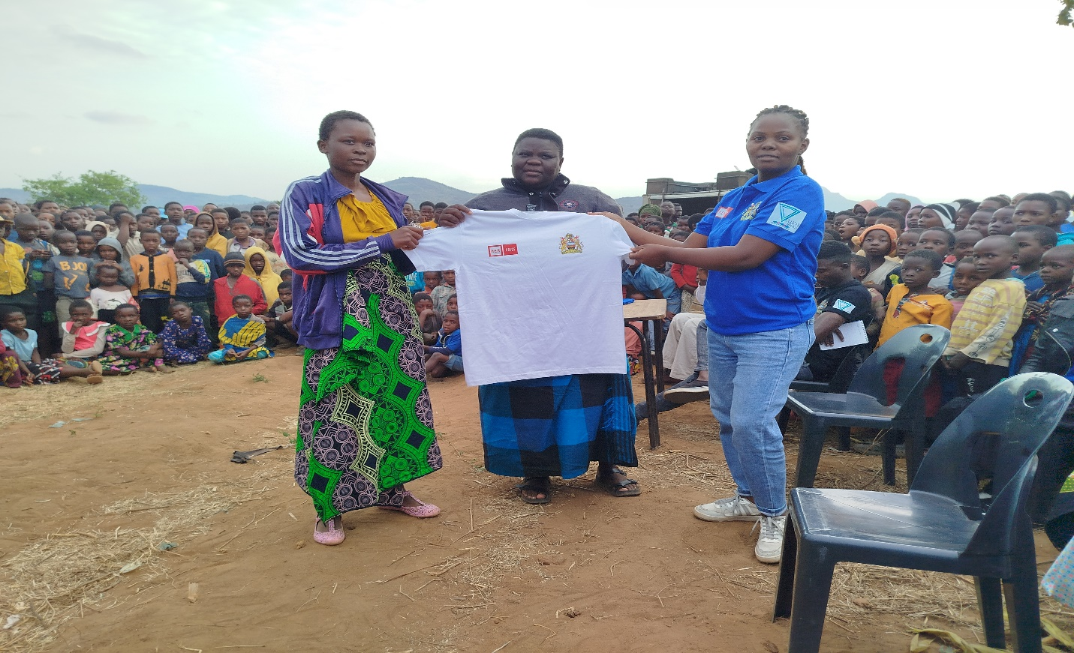
Awarding of branded t-shirts to best netball performers by Group Likumba and YWCA

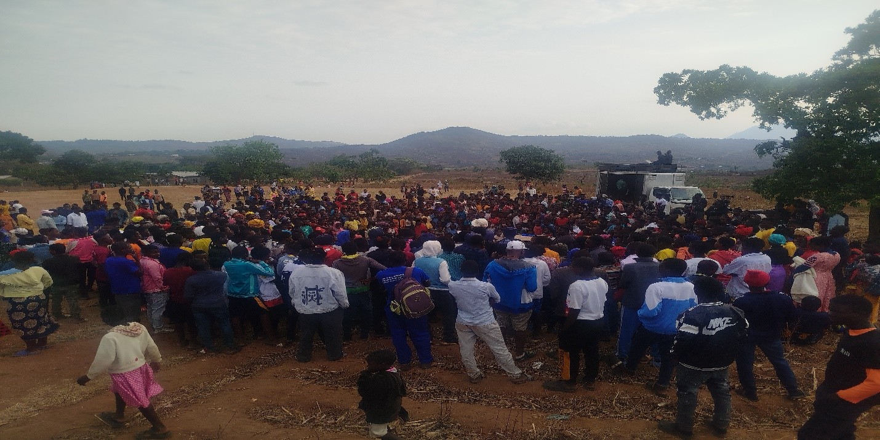
Community members gathered getting ready for the football Bonanza awards ceremony

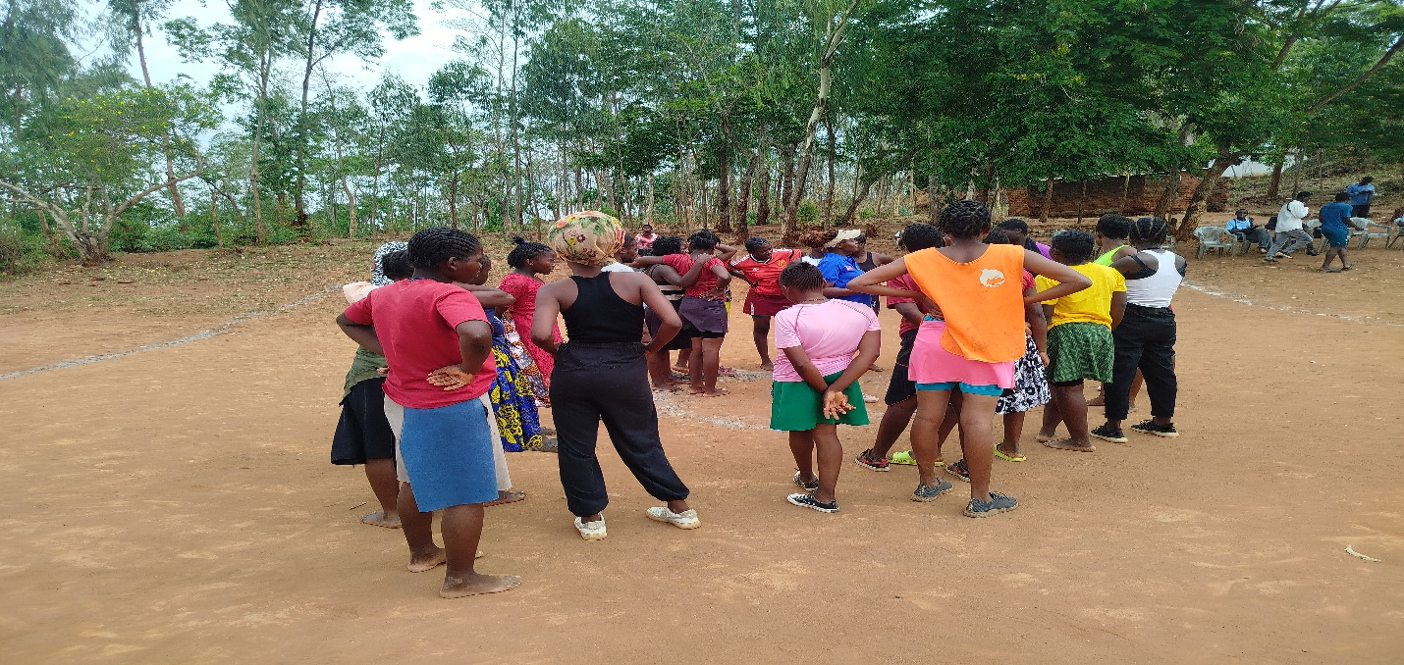
Interactive sessions on health-related topics with youth (Ntenje)

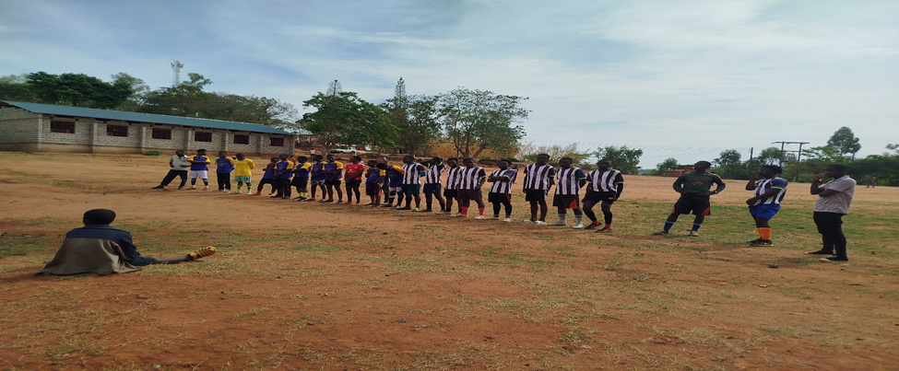
Ntenje and youth network team line-up in preparation for the match (Seyama Ground)
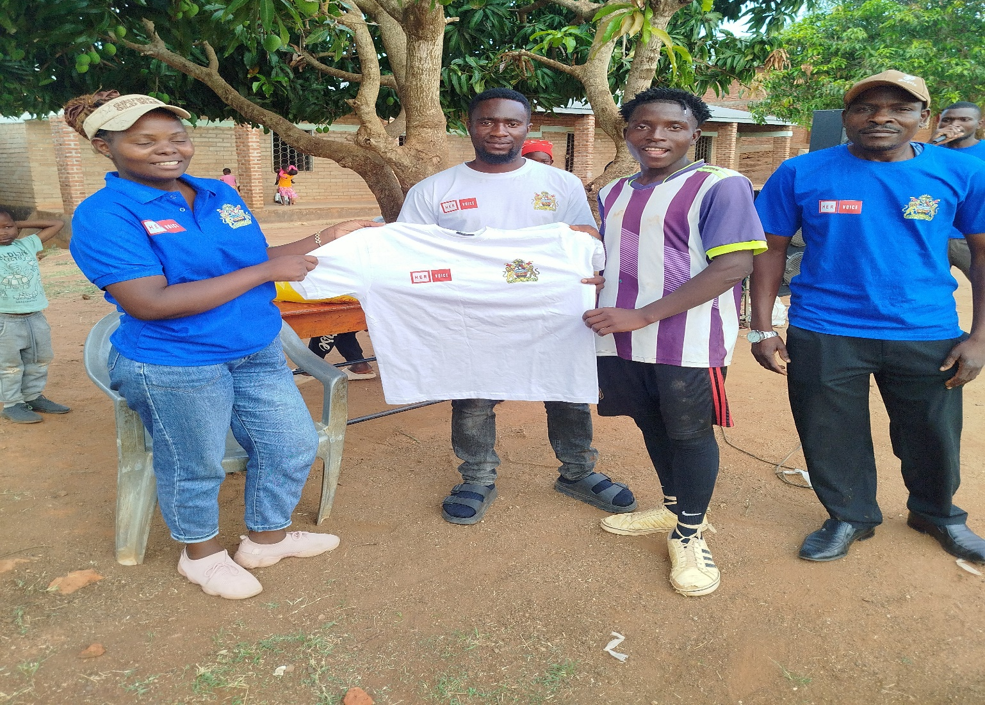
Awarding branded T-shirt to best performing player
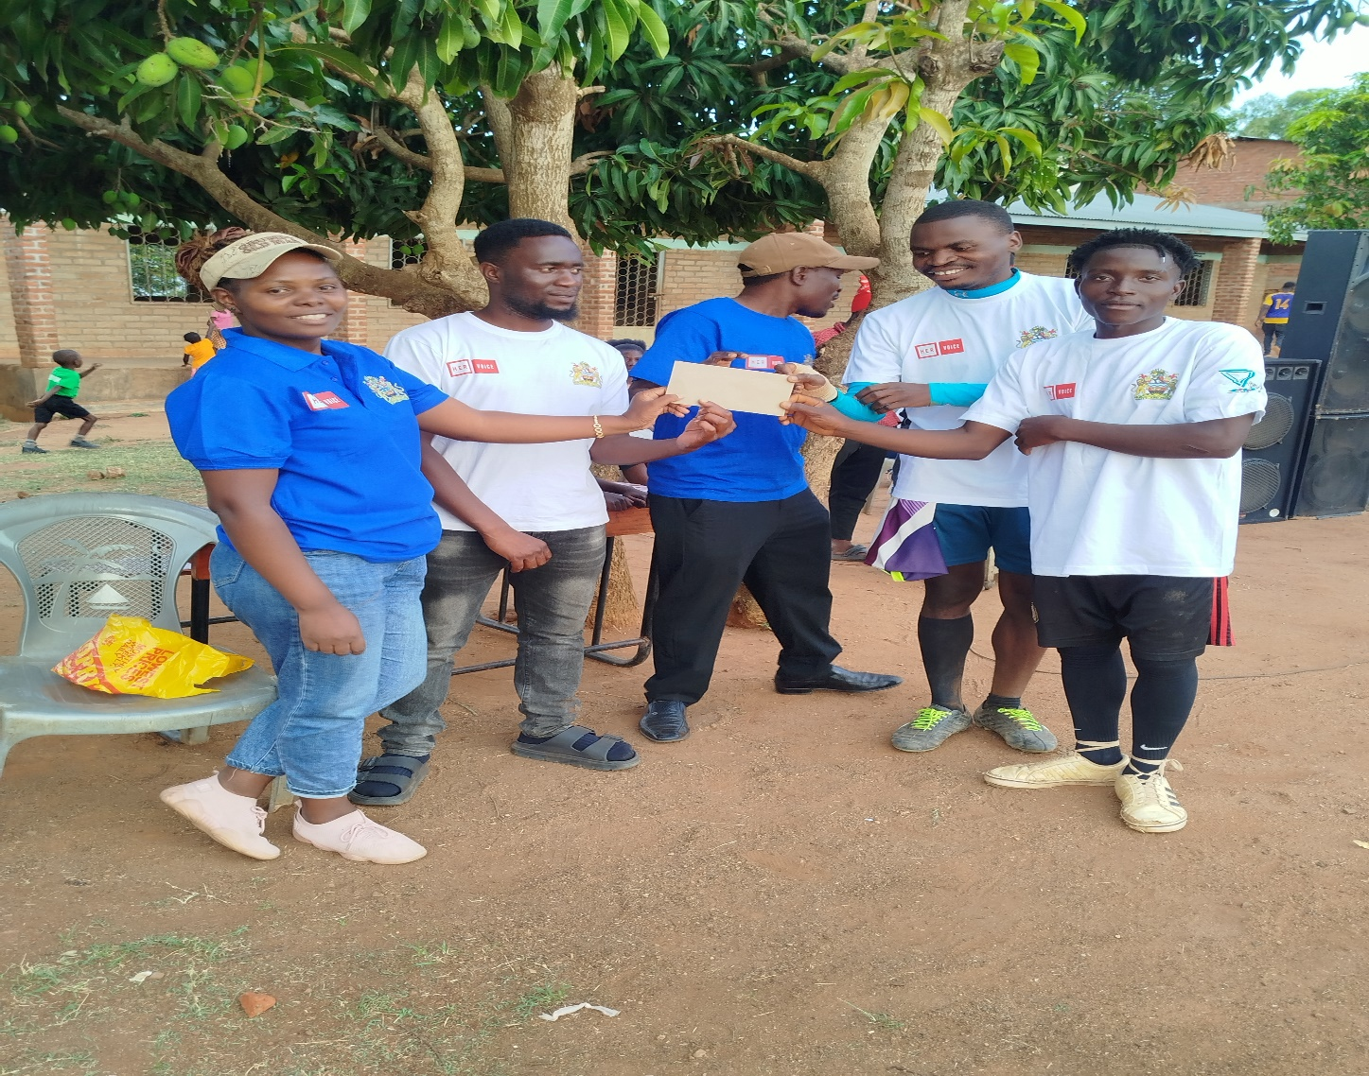
Presentation of award (Money) to the winning team: Ntenje

Annexe 2

MINISTRY OF HEALTH
BLANTYRE DHO
REPORT ON COMMUNITY BASED OUTREACH CLINICS
LOCATIONS: Malunga B
Chipande H/C
Mtenje/ Chigumula :

ACTIVITY DATES : 12 May 2025
: 15 May 2025
: 28 May 2025.

SUPPORTING PARTNER : HER VOICE FUND YWCA PROJECT

REPORTED TO: YWCA
: DHSS Blantyre
: DNMO Blantyre
: FP CORD Blantyre
:

COORDINATORS INVOLVED

- LYDIA MPALIRA  (MOH, YFHS COORD _ BLANTYRE DHO)
- MILLICA MSUMBA  (MOH, CBDA COORD  BLANTYRE DHO)

INTRODUCTION
Modern family planning methods are very reliable, effective and safe to use to all people of child bearing age including the youths (10 – 24yrs) as they also indulge in sexual activities. However, access to modern family planning methods has been a challenge to them due to inadequate providers, shyness and long distances to access modern family planning methods. Most youths find it hard to open up to older providers, living a reserved life which has resulted into adolescent pregnancies, teen mothers, unsafe abortions and more sexually transmitted infections among them.
In order to increase the uptake of SRH/HIV services by young people, YWCA in conjunction with Youth Friendly Health Services and the Community Based Family Planning Services with financial support from HER Voice Fund, conducted outreach clinic sessions on the dates mentioned above within T/A Machinjiri targeting YFHS providers from 3 health facilities across both ADCs. The following cardres from the 3 Health Centers participated in the delivery of services; Community Health nurse /FP Focal Person, HSAs from the catchment area, Supporting HSs, Clinician, HTS provider, Mobilisers, Volunteers and CBDAs. A total of 35 participants took part in this activity.
HEALTH EDUCATION
At all sites health education was done on Measles, Modern Family Planning Methods and Asthma.
Date | Health Facility | Site | Attendance |  |  |  | # of People Counselled for HTS Female(Male) | # of people Tested for HIV | Results | # Self-Test kits distr. | # of self-testing kits ordered
Date | Health Facility | Site | Age Category | M | F | Total
12 May | AMECA | Malunga B Village clinic | 10 -24 yrs | 12 | 25 | 37 | 20 | 20 | 20 | 41 | 50
12 May | AMECA | Malunga B Village clinic | 25 -35 yrs | 0 | 15 | 15 | 20 | 20 | 0 | 41 | 50
15 May | South Lunzu | Chipande H/P | 10 -24 yrs | 21 | 69 | 90 | 32 | 32 | 32 | 62 | 70
15 May | South Lunzu | Chipande H/P | 25 -35 yrs | 20 | 11 | 31
28 May | Limbe | Mtenje Village clinic | 10 -24 yrs | 7 | 10 | 17 | 17 | 17 | 17 | 63 | 70
28 May | Limbe | Mtenje Village clinic | 25 -35 yrs | 4 | 9 | 13
Summary |  |  | 10 -24 yrs | 40 | 104 | 144 | 69 | 69 | 69 | 166 | 190
 |  |  | 25 -35 yrs | 24 | 35 | 69 | 69 | 69 | 0 | 166
GRAND SUMMARY |  |  |  | 64 | 139 | 213 | 138 | 138 | 138 | 166 | 190

Date | Health Facility | Ground | # of People Counselled for FP | # of females injected with Sayana | # of Females serviced with Coc's | # of people received EC | # of people diagnosed STI | # of male condoms distri. | # of male condoms ordered
12 May | AMECA | Malunga B Village clinic | 40 | 52 | 0 | 0 | 13 | 360 | 576
15 May | South Lunzu | Chipande H/P | 121 | 67 | 9 | 0 | 15 | 576 | 720
28 May | Limbe | Mtenje Village clinic | 52 | 47 | 0 | 0 | 9 | 600 | 720
Summary |  |  | 213 | 1168 | 9 | 0 | 27 | 1536 | 2016

Besides the above services general outpatient management were also done at all the three places.
OUTCOMES
- Outreach done as per schedule
- People were educated on the recent outbreak of measles in our country and how to prevent it.
- Comprehensive package of services were rendered.
- AGYWs in rural areas were able to access SRHR/HIV services
CHALLENGES
- Some services demanded by AGYW were not met because of unavailability of experts in that field i.e Laboratory technician and NCD nurse.
- There was a funeral at Malunga Village which affected turn up of the people
- Some FP methods of choice were not provided due to stock out and also lack of trained personnel for instance two AGYWs wanted Hormonal IUCD.
- CBDAs complained of not getting enough supplies and that other services like pills were out of stock for quite some time and condoms were not given enough
RECOMMENDATIONS
- To order enough stocks so that clients should not be sent back without getting their FP method of their choice.
- This activity needs to be done often because in some places H/C are very far for people to access health services. And if they do, not all health service providers are available on the day of the clinic

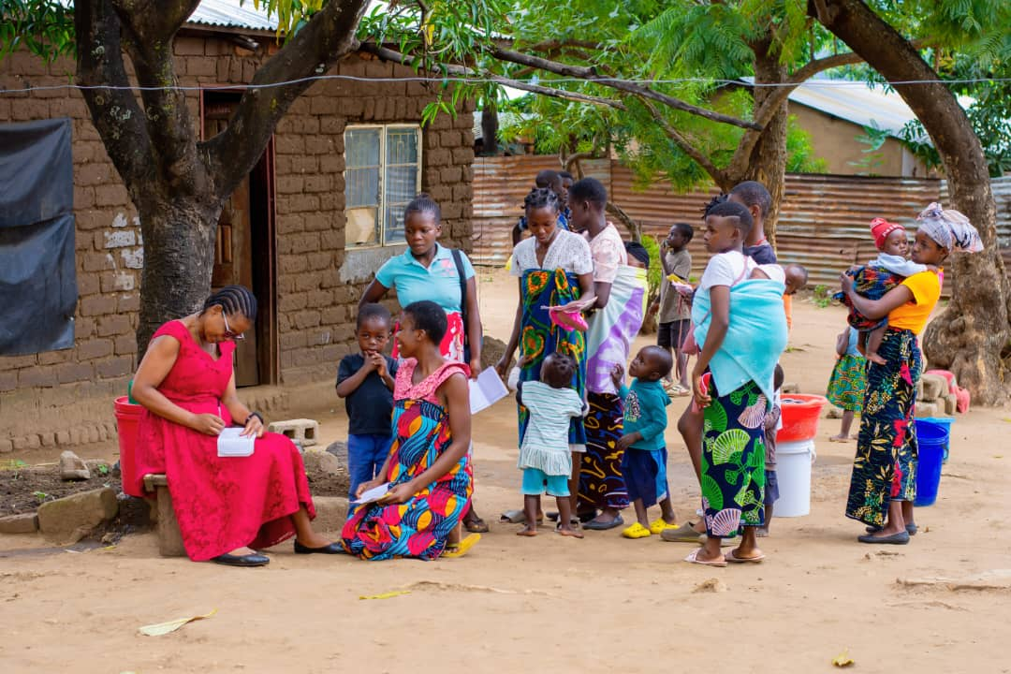
Figure 9: Clinician Dorothy Munthali attending to AGYW with under 5 babies at Malunga Village

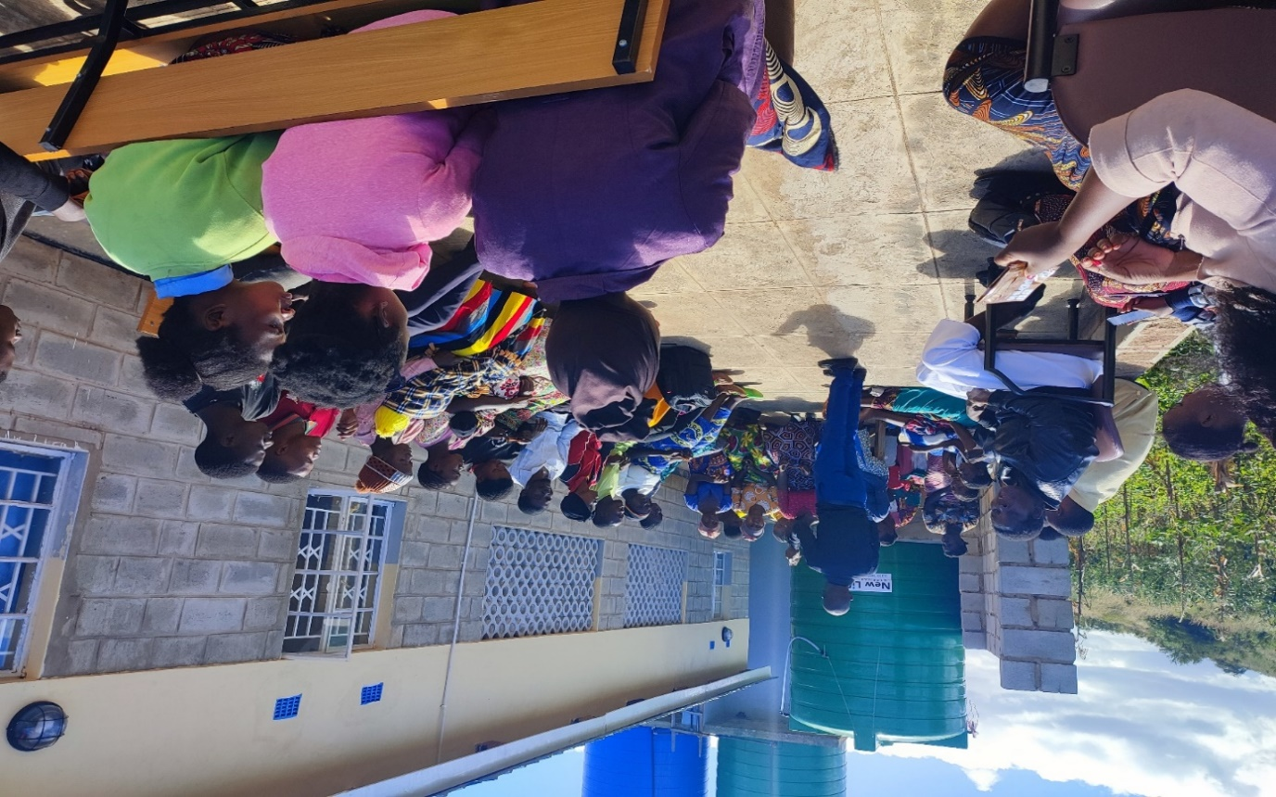
Figure 10: CBDA Supervision for South Lunzu H/C Mr Felibouy delivering health talk to youths on SRHR/HIV at Chipande H/C
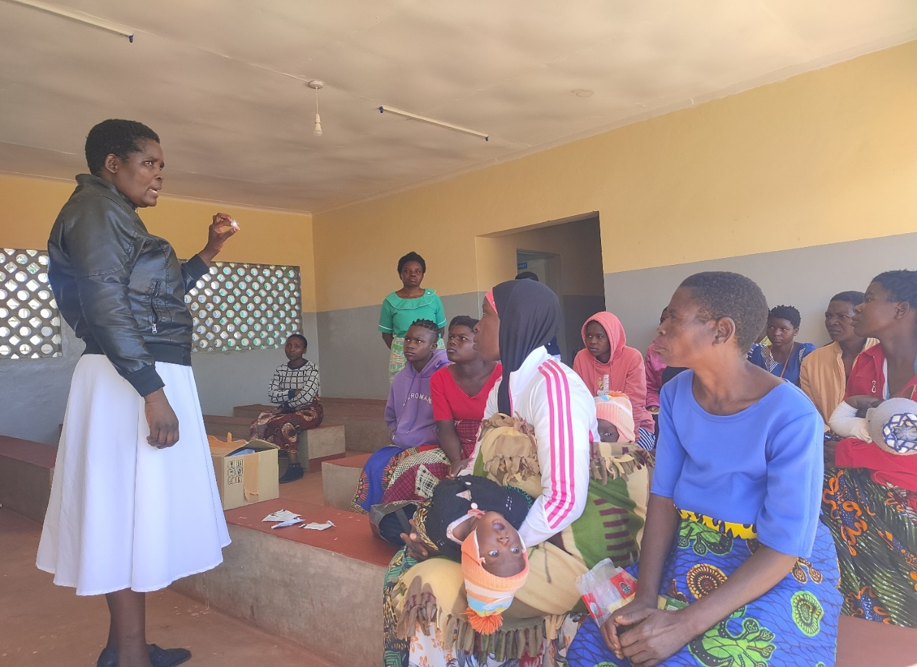
Figure 11: CBDA Coordinator Millica teaching AGYW on self-injecting method

MINISTRY OF HEALTH
BLANTYRE DHO
REPORT ON COMMUNITY BASED OUTREACH CLINICS
TO: The Project Manager YWCA Blantyre.
CC : DHSS Blantyre
CC : DCNMO Blantyre

DATE: 15 December, 2025

From: Community Based Distribution Agents Coordinator

KASUPE CBDA/YFHS DECEMBER 2025 OUTREACH REPORT.
With funding from Young Women Christian Organisation under HER VOICE Fund the mentioned programs jointly conducted an outreach clinic at Makwerani village to reach out to Youths. This is so because most youth don't have access to SRH services owing to long distances to clinics and or money to access these services. It is against this background that we conducted this outreach clinic.
Activity Date: 10 December 2025
Place: KASUPE CBCC at Makwerani Village.
The following activities were done
- Health Education on Sexual and Reproduction Health rights
- Distribution of Family Planning methods to Youths
- Blood Pressure screening to the youths as well as others
- HIV testing
- Out Patients Clinical Services to the AGYW their children and others.
The table below summaries the whole activity
Service | Up to14 years old | 15 -19 years old | 20-24 years old | 25+years | Total
Family Planning | O | 2 | 4 | 8 | 14
HIV testing | 1 | 6 | 2 | 10 | 19
NCD BP screening | 0 | 10 | 9 | 48 | 67
Out Patients Clinical Review | 13 | 2 | 3 | 24 | 42
General Counselling | 31 | 0 | 0 | 0 | 31
MRDT Lab services | 6 | 0 | 0 | 6 | 12
Totals | 41 | 20 | 9 | 48

Table showing number of FP clients disaggregated by method
Method | Females | Males | Couples
COC | 2 | 0 | 0
POP | 0 | 0 | 0
Female Condoms | 0 | 0 | 0
Male Condoms | 2 | 5 | 0
Sayana Press | 5 | 0 | 0

SUCCESS STORY
- Able to reach young boys as well with family planning.
- One Youth was screened for BP and had a High BP of 189/99 which we referred for continuation of care at the clinic.
- Another story is of a youth who defaulted on ART and said she feared to come to clinic but after counseling she agreed to come back to care.
STRENGHS
Able to conduct an outreach.
WEAKNESSES
Low turnout of Youths owing to the day being a school going day so most Youths were in class. For the out of school youth most of them were in the field applying fertilizer as it had rained the eve of the activity.
WAY FORWARD
To offer the outreach clinic in the afternoon hours when both school going Youths and out of school Youths are free.

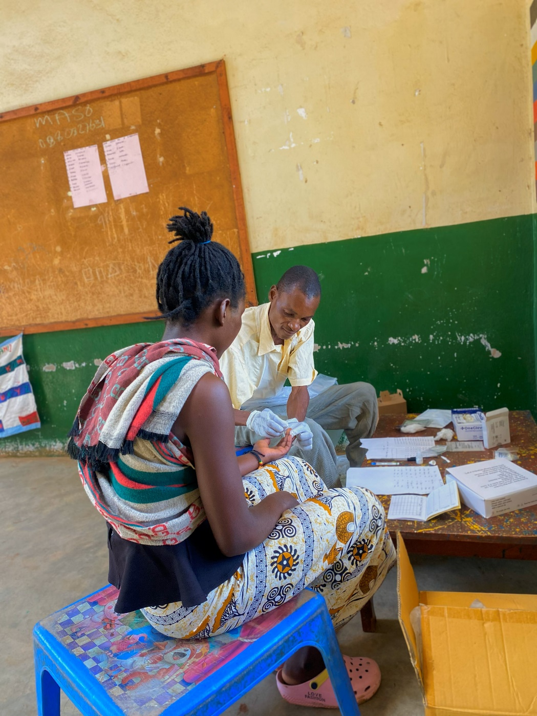
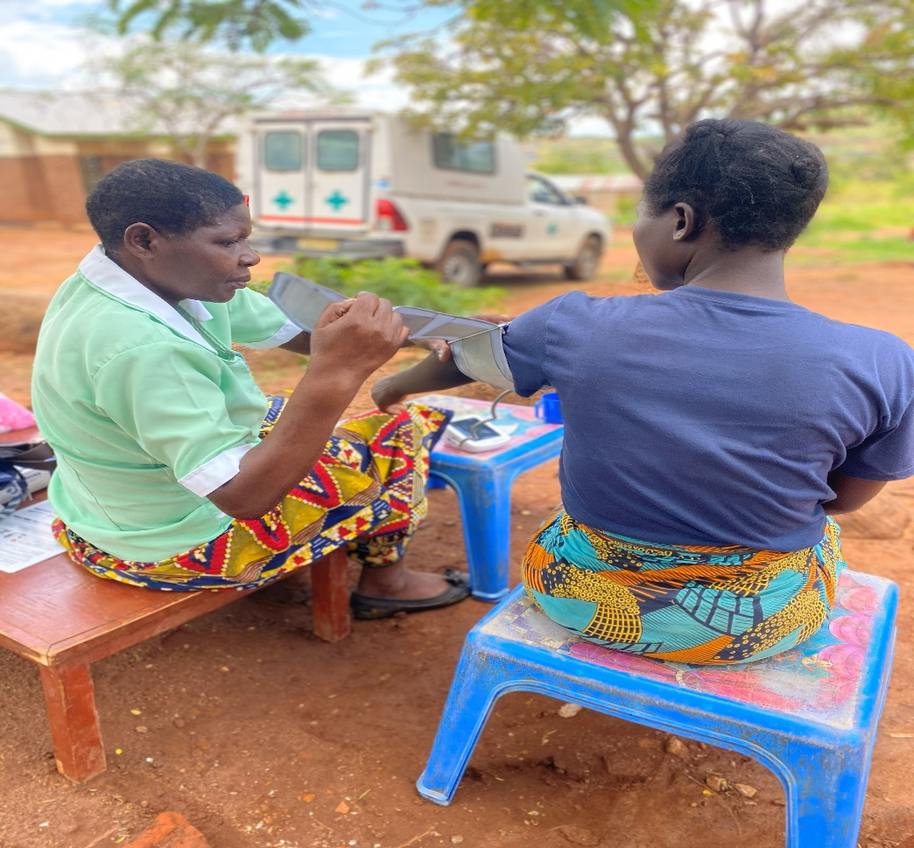

Submitted by
Millica Msumba Kalolo

